Task 1 : Odd and Even Number
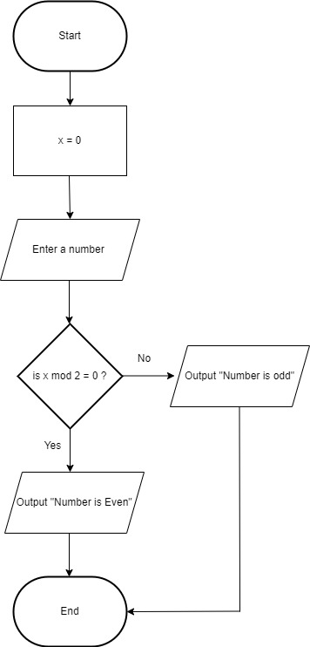

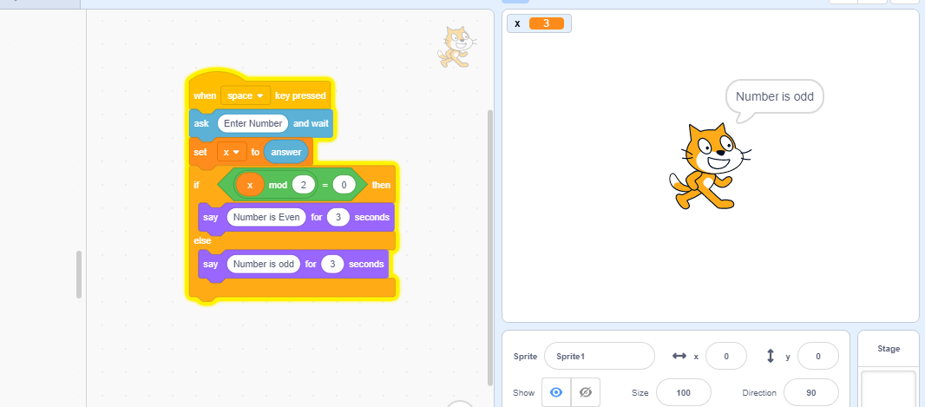

Task 2 : Marksheet
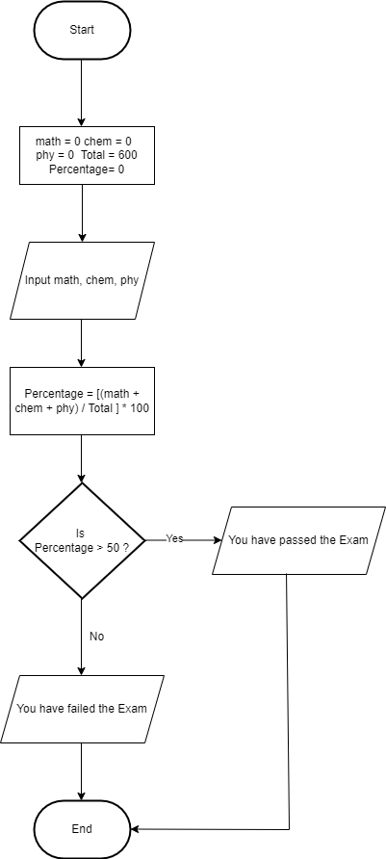

Task 2 scratch:
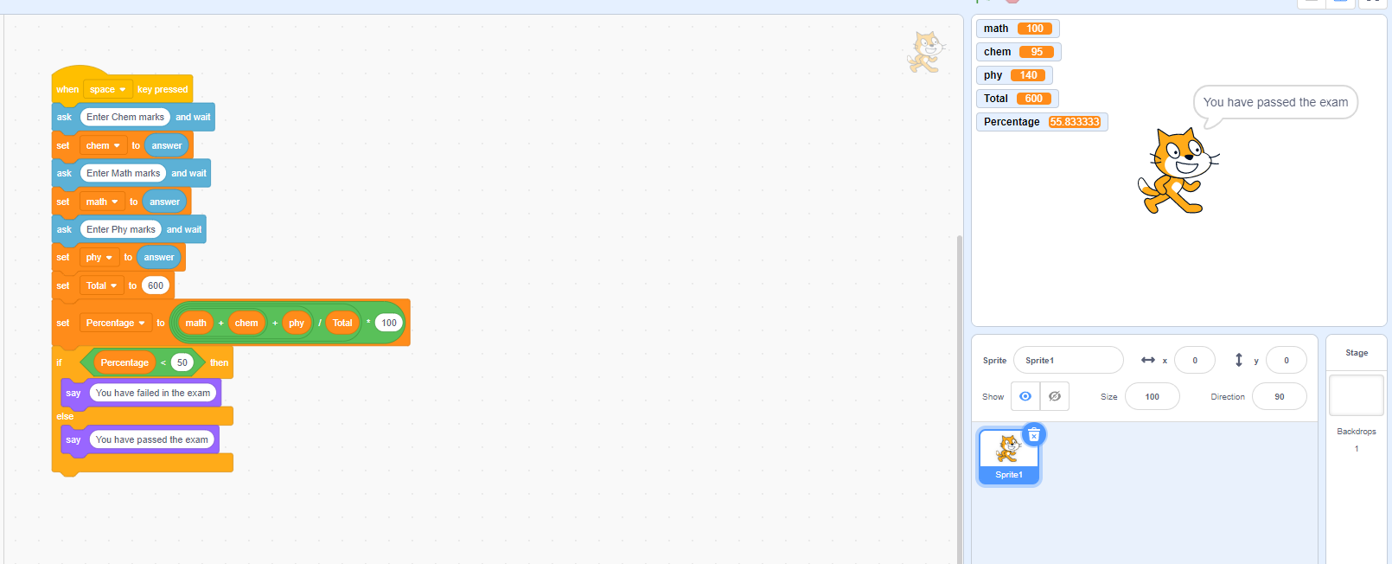

Task 3 (Scratch – Square):

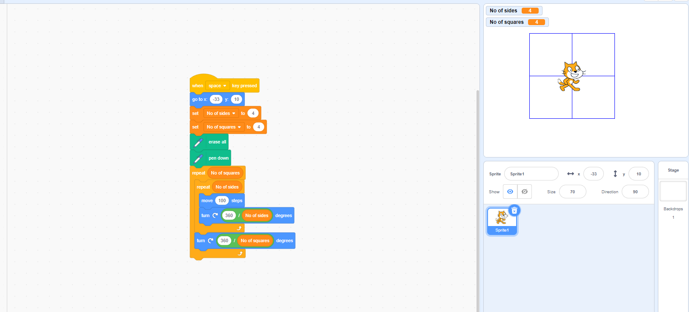

TASK 4:
Iterative structure used in this task is For to next loop, and an increment is done to the counter as soon as the task is done if the counter is less than the required condition.
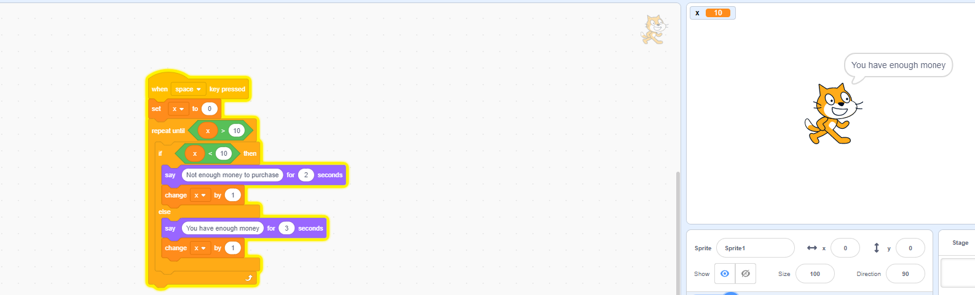
TASK 5 :
In this program, A number is set to a specific value then an iterative loop is applied to achieve a smaller number.
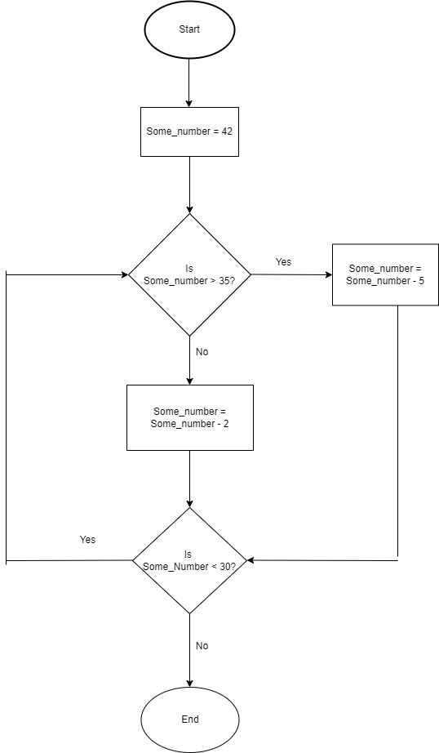

TASK 6: (PRIME NUMBER)
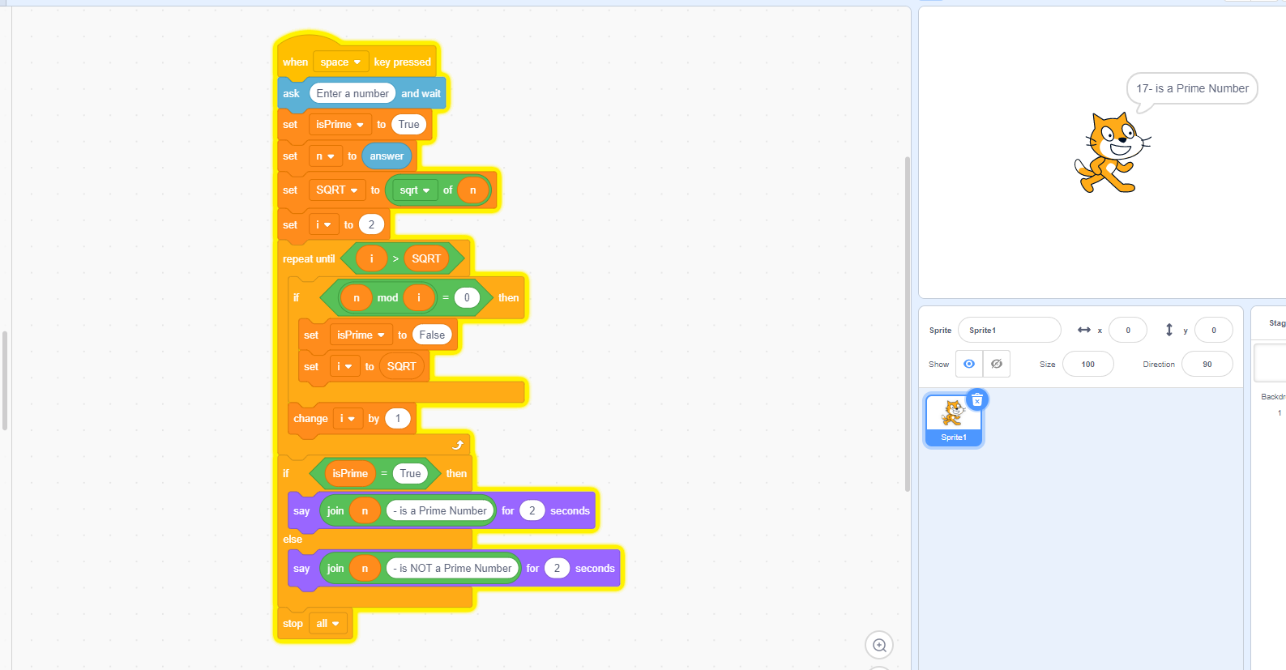

TASK 7: (FACTORIAL)

